Moving the Needle

A study of the relationship attitudes towards police and vaccine hesitancy amongst

African Americans

Isha Negi  
*Department of Systems Engineering and Engineering Management,*  
*George Washington University*Washington, District of Columbia  
ishanegi29@gwmail.gwu.edu

Neel Bhagwat  
*Department of Systems Engineering and Engineering Management,*  
*George Washington University*Washington, District of Columbia  
bhagwatn2021@gwmail.gwu.edu

David Broniatowski  
*Department of Systems Engineering and Engineering Management,*  
*George Washington University*Washington, District of Columbia  
broniatowski@gwmail.gwu.eduSanskriti Shivhare  
*Department of Systems Engineering and Engineering Management,*  
*George Washington University*Washington, District of Columbia  
sanskriti21@gwmail.gwu.edu

***Abstract*— Past literature has examined the causes of vaccine hesitancy amongst African Americans. Multiple causes of vaccination reluctance were found like attitudes towards law enforcement, trust in the healthcare system, susceptibility to misinformation, socioeconomic and accessibility factors, perceived discrimination, perceived risk, trust in the government, and political affiliation [1,7]. Another study in 2021 established that the attitudes towards the police are a driving force of vaccine hesitancy amongst African Americans, driven by historical injustices in public health policing, such as a forced-at-gunpoint vaccination campaign directed towards African Americans in Middlesboro, Kentucky in 1898 [8]. We further investigated the 2021 study by controlling for the various covariates found in the literature, particularly government trust. Using data from the 2020 and the 2016 American National Election Survey, as well as ZIP-code level data from 2020-2021 in NYC on arrests, vaccine rates, accessibility, and socioeconomic factors, we sampled from African American respondents in the ANES survey as well as African American-majority ZIP codes in New York City to investigate whether a causal relationship exists between police attitude and vaccine hesitancy inAfrican American community.**

**We spread our experiment across three quasi-studies - our first study is posttest-only using ANES data, to control for numerous confounders that arose in 2020. Our treatment group is respondents that had better attitudes towards police in 2020, our control group is respondents that had worse attitudes towards the police in 2020. The other study uses 2016 ANES data as a pretest, where the treatment and control group is split by attitudes towards the police in 2020. The last study uses ZIP code-level data from NYC, splitting treatment and control by the amount of arrests per capita from May 2021 to October 2021, with COVID-19 vaccine dates before and after this timeframe as our pretest and posttest outcome variables.**

**We found that police attitudes are controlling with vaccine hesitancy amongst African Americans when controlling for other factors identified in the literature, but police attitudes only influence intention to vaccinate, especially attitudes towards vaccine mandates, while actual vaccine uptake may be associated with other factors such as accessibility, perceived discrimination, and susceptibility to misinformation. The influence that police attitudes have on attitudes towards vaccine mandates are indicative of mistrust in the government driven by interactions with police. It is important to note that our study has limitations that hinder the robustness of our findings - further research should combat these limitations. We give recommendations to decision makers and researchers on how to avoid these limitations in further research.**

***Keywords— vaccine hesitancy, police attitudes, vaccine uptake, public health equity, criminal justice in public health***

# Introduction

The COVID-19 pandemic is going on its third year, especially as undervaccinated communities breed new variants that evade the immunity of current vaccines [6].Vaccines have been credited with saving countless lives in the past, making them one of the most significant medical advancements in human history. However, a range of influences, including systemic political, religious, racial, and educational ones, have contributed to a culture of rising skepticism regarding such medical advancements. Vaccine hesitancy is a threat not only for the COVID-19 pandemic, but also ongoing and future health crises. According to numerous public health literature sources, African Americans are less likely to get vaccinated [3, 9, 10]. Multiple factors contributing to vaccine hesitancy have been described in the previous literature that we studied. Research shows that medical distrust is higher in ethnically diverse populations, which is supported by historical injustices, discrimination, and adverse health care experiences [11]. A significant aspect underlying general health disparities is mistrust in the healthcare system in tailoring to and validating individual experiences [1,3]. It has been observed that the African American community have negative opinions about vaccines as they perceive discrimination in the healthcare system due to the unethical diagnostic procedures and research carried out in their community in the past [1,3]. The public's perception of weighing the potential risk alternatives of contracting the disease or suffering from vaccine side effects is key in determining whether or not to get immunized [2,7]. Political polarization in vaccination rates tends to be a typical U.S trend, representing the views of the general public on regulations and data provided by the government. A study found that respondents respected the word of healthcare professionals more than elected government officials regarding getting vaccinated as they suspect political representatives' intentions [3]. Studies illustrate that Democrat party voters and liberals are more inclined to get immunized, which reflects the fact that political affiliation has substantially increased the disparities in immunization coverage [2,7].According to survey findings, people who live in economically underprivileged areas and have lower incomes and educational backgrounds are less likely to receive vaccines as they are unaware of the provision of vaccination insurance coverage.Online misinformation concerning the COVID-19 vaccine has been linked to decreases in vaccination rates and inoculation in various parts of the United States. The spread of anti-vaccination sentiment in the public has been facilitated by discussions of unfounded theories based on misunderstandings or misrepresentations of science, religion, exaggerated claims about side effects, ambiguity of the immune system's functioning after vaccination, and other false or distorted information.This has affected the public attitudes and beliefs about the safety and efficacy of vaccines [3, 5, 7]. Equitable access to high-quality healthcare is made possible by the necessity of affordable and accessible vaccination distribution, particularly for disproportionately affected groups [5].

A 2021 study studied the relationship between vaccine uptake and police attitudes towards African Americans. Attitudes of police, who are considered as the face of government by some African Americans, make some people hesitant to trust the government that vaccines are safe, or question the government’s intentions [8]. The study found that police brutality towards racial minorities like African Americans causes vaccine hesitancy, but did not control for other factors [8]. However, the study is consistent with other research on police involvement in public health. According to other research, hesitancy to follow public health guidance stems from over policing of African Americans when enforcing public health mandates (68% of all COVID-19 restriction-related citations in NYC were African Americans, NYC has a 24% African Americans population) [4], and the fact that African Americans have less opportunities to avoid police, as more work in essential services [4]. We expand on this study by testing the relationship between attitudes towards the police and vaccine hesitancy amongst African Americans when controlling for the other factors identified in the literature.

# Sampling

1. *Unit of analysis*

Our unit of analysis is individual African American respondents who took the American National Election Survey in 2020 and 2016 - we would like to know the attitudes and opinions on key issues related to vaccine hesitancy of individual African Americans, surveying African American individuals would serve that purpose.

We are studying ZIP code-level geographical data as we would like to see how interactions with the police in different areas may influence vaccine uptake - while we may be studying people we would be analyzing ZIP codes as a whole, thus ZIP-codes are also our units of analysis.

1. *Theoretical population*

Our target population on which we are interested to generalize our findings will be the African American community across the US. Since we aim to find vaccine hesitancy in various sections of the country, African American individuals from different communities serve as part of the population of interest in our study.

1. *Sampling strategy*

The ANES survey respondents are recruited at random - every resident of the United States (including Washington DC) has an equal chance of being selected - respondents randomly drawn from USPS delivery sequence data. By using this dataset, we are adopting the sampling strategy of this study employing simple random sampling (probability sampling) on our theoretical population - African Americans are randomly selected for this study.

For the NYC study, we are employing modal instance sampling as we are gathering data about ZIP codes in the largest municipality in the country, so we are under the assumption that New York City is the “modal” city. While it is ideal to use data from multiple cities throughout the country, data from one major city can be considered as a good start.

1. *Accessible population*

The scope to consider the whole african american community in the US for vaccine hesitancy is too large and, hence, difficult to sample. Respondents from the ANES surveys in 2016 and 2020 can serve as our accessible population as the study is nationally representative and contains African American respondents.

NYC residents: It would be out of scope for us to get data on arrests and vaccine rates across the entire country. We would have to go through multiple public health and police departments’ websites. We selected New York City to obtain data from as it is the largest metropolitan area in the country and may give us the largest sample size.

1. *Sampling frame*

The ANES survey includes all the respondents from different communities of the country. In order to maintain homogeneity in our sample, we decided to use only the responses from African Americans in ANES 2016 and 2020 surveys as our sampling frame.

Counties with at least a 30% African American population in NYC - we can’t obtain all the African Americans in the city, so we decided to take counties with at least a 30% African American population.This is done in order to control for other races and find out whether the relationship between police and vaccine rates is embedded in systemic racism.

1. *Sample Size*

The records in the ANES studies which are derived from the sampling frame after data cleaning process (we want to filter out inapplicable and incomplete responses) may be reasonably representative of the target population, African American community - after cleaning we obtained a sample of 726 respondents from 2020, 164 of them who took the 2016 survey. This will be the final sample which would help derive findings related to vaccine hesitancy.

For the NYC study, the sample size is 178 zip codes according to the US Census Bureau. However, it is important to note that the population of New York City is 8.804,190.

1. *Threats to external validity*

Sampling strategy: The random sampling of respondents by ANES may introduce biases toward particular locations or subpopulations. This necessitates the addition of more information about subpopulations in order to make stronger claims about our data. A better approach for ANES would be to consider stratifying their sample by location, given that they have address-specific USPS data to use.

The final sample size for the first study involving ANES 2020 data is a fairly small count of 726. The sample size for the second study constitutes only 164 data entries.Moreover, our sample likely does not contain responses from various subpopulations, which compounds on the problem that we don’t know the specific subpopulations to begin with.

Also, the NYC study comprises data of only one city and, hence, does not include samples from residents in the other cities. It is not representative of the entire nation and the findings cannot be generalized to all the communities. Also, the dataset is not only about the African American community as people of other races live in the ZIP codes in NYC as well.

# Measurement strategy

Using factors on the literature on vaccine hesitancy [1-10], we identified a series of constructs that we can measure using the data we sampled and answer our question.

1. *Trust in the government*

Vaccine hesitancy is often driven by an overall mistrust of the government in the sense that people do not trust the word of government officials that vaccines are safe. For African Americans, police can be “the face of government” to them, but an overall mistrust in the government may be distinct from mistrust induced by police interactions, thus it is a confound [3,8].

1. *Attitudes towards law enforcement*

Attitudes towards law enforcement, driven by historical injustices with policing of public health, is thought to be a cause of vaccine hesitancy [4,8].

1. *Interactions with law enforcement*

Interactions with law enforcement, which can be measured by counting the number of arrests and stops, coupled with historical injustices with policing of public health, may influence attitudes towards law enforcement [8].

1. *Trust in the healthcare system*

Historical injustices in the healthcare system, such as the Tuskegee Syphilis Study may influence attitudes and beliefs about vaccines [8]

1. *Political activity*

Conservatives have historically been more vaccine-hesitant [8] whereas liberals have been open to adopt vaccination measures.

1. *Perceived discrimination*

Past literature has studied the link between perceived discrimination and vaccine uptake [7]. The medical inequity has resulted in negative opinions of the healthcare system amongst African Americans.

1. *Susceptibility to misinformation* - link between perceived discrimination and vaccine uptake [7,8]
2. *Vaccine uptake* - This is a measure of a behavioral outcome we are interested in analyzing for our study.
3. *Attitudes towards vaccine mandates* - reflective of the mistrust in African American community towards the government [8]
4. *Socio-economic factors* - income, education level may influence access or beliefs about the vaccine [8]
5. *Severity of epidemics* - may influence perceived disease risk [7]

Table 1 contains the table of features that were chosen to measure the constructs of the study.

| **Construct** | **Feature** | | | **Scale** |
| --- | --- | --- | --- | --- |
| **Trust in the Government** | Level of corruption in government  Respondents’ voice in government  Do big interests dominate the government?  Does the government value people’s opinions?  Does the federal government maintain integrity?  How much tax money does the government waste?  Does the federal government treat African American or Whites better? | | | Interval |
| **Trust in the**  **healthcare system** | Scientists feeling thermometer  Confidence in medical institutions  Confidence in the scientific community  Importance of science in COVID-19 response  World Health Organization feeling thermometer  Centers for Disease Control feeling thermometer | | | Interval |
| **\*Attitude towards law enforcement** | Excess police force used  Police feeling thermometer  Are COVID-19 restrictions too strict?  Federal budget spending on combating crime  Federal Bureau of Investigation feeling thermometer  In response to the 2020 BLM protests, should we enact police reform or use force to quell unrest? | | | Interval |
| **\*Interaction with the law enforcement** | Arrest rate | | | Ratio |
| Have you or anyone in your family been arrested?  Have you or anyone in your family been stopped by police? | | | Ordinal |
| **Political**  **Activity** | Pay attention to politics/elections?  Presidential candidate preference, 2020 | | | Ordinal |
| Party affiliation (Democrat/Republican)  Political affiliation (Liberal/Conservative)  Republican presidential feeling thermometer  Democratic presidential feeling thermometer | | | Interval |
| **Susceptibility to Misinformation** | Do the health benefits of vaccines outweigh the risks? | | | Interval |
| Do vaccines cause autism?  Was SARS-CoV-2 developed in a lab?  Is hydroxychloroquine an effective treatment for COVID-19? | | | Ordinal |
| **Socio-economic factors** | Income  Person with a college degree  Commute time (accessibility) | | | Ratio |
| **\*Vaccine Outcomes** | Does the respondent support vaccine mandates in school? | | | Interval |
| Has the respondent put off healthcare checkups or vaccines? | | | Ordinal |
| COVID-19 vaccine rate | | | Ratio |
| **Severity of epidemics** | COVID cases rate | | | Ratio |

Table 1. Features to measure constructs

After obtaining these features, we performed a factor analysis to perform dimensionality reduction and identify the most useful variables that would contribute to the variance of our dependent variables.

1. *Validity*

Using the literature, we can assert the content

validity of our measures - our measurements are backed by the literature in how they are related to the constructs and how the constructs are related to our hypothesis question.Moreover, we can affirm the convergent and discriminant validity of our measures using correlation matrices for each study, identified in Figures 3(a), 3(b), and 3(c). We can observe from the figures that the similar items are correlated, particularly for our constructs of interest (police attitudes, government trust, outcome variables), and that the items that are related to different things (socio-economic factors, perceived discrimination, etc.) are uncorrelated with most of our variables of

interest.

Study 1

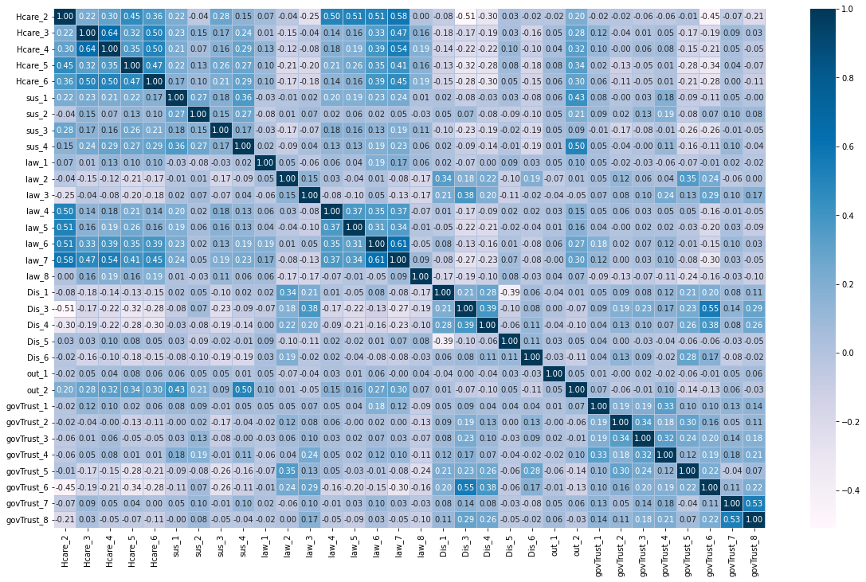

Figure 3(a). Correlation between Study 1 Attributes

The figure 3(a) shows the correlation between the attributes in Study 1. It depicts that there exists a significant relationship between the healthcare and the law variable group.

Study 2

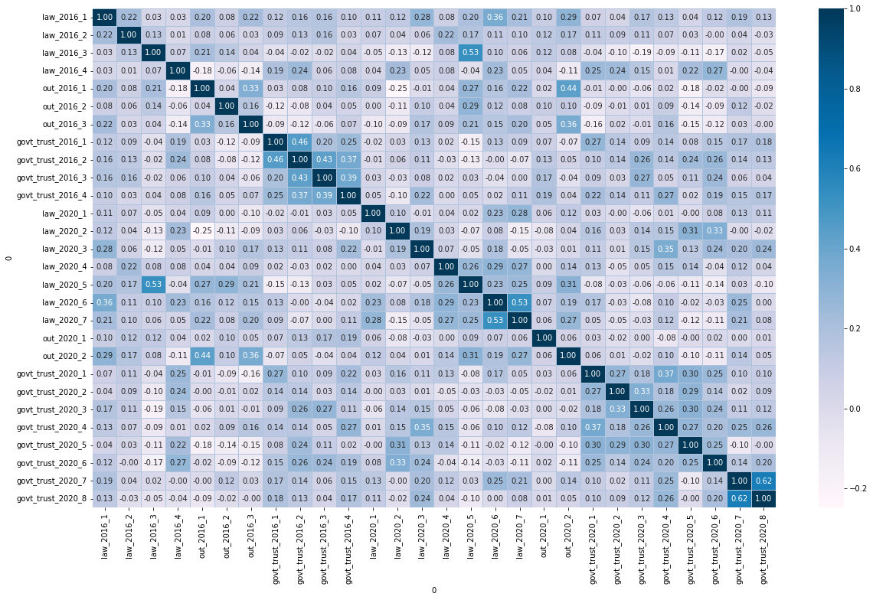

Figure 3(b). Correlation between Study 2 Attributes

The figure 3(b) shows the correlation between the attributes in Study 2. It depicts that there is a significant relationship between the trust in government in 2016 , trust in government in 2020 and the law features group. This helps us in understanding that these features play an important role..

Study 3

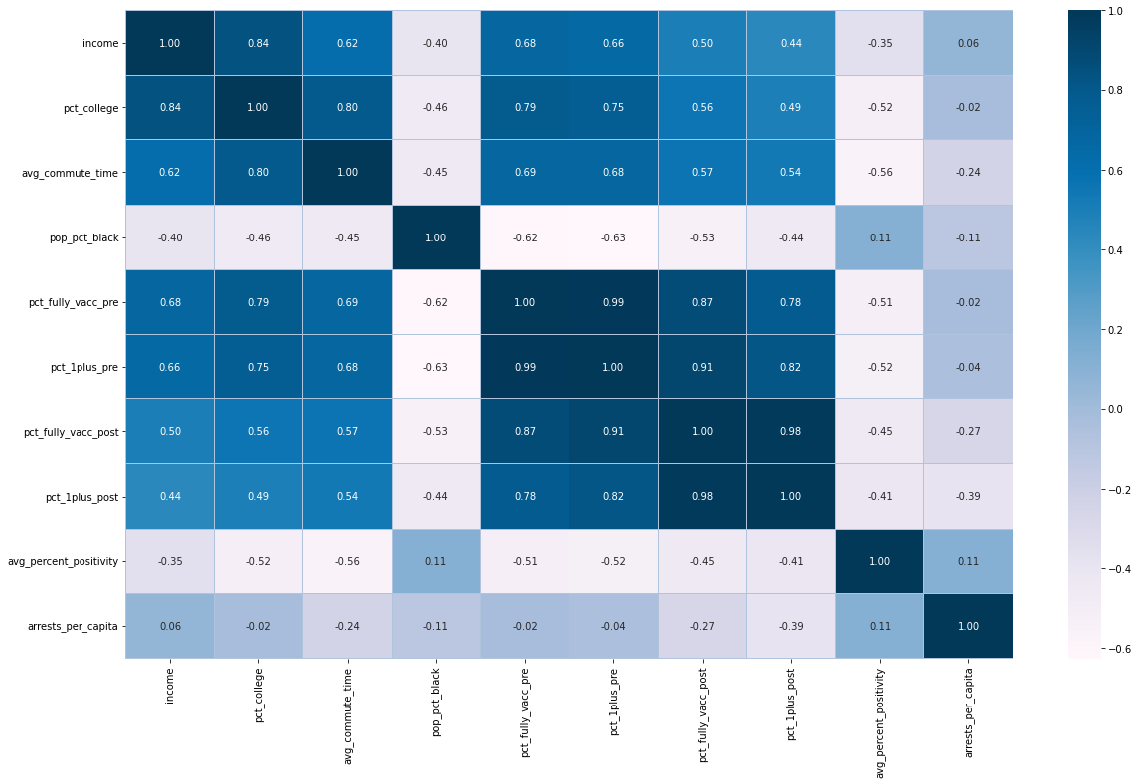

Figure 3(c). Correlation between Study 3 Attributes

The figure 3(c) is the correlation between the Study 3 features. This shows a strong relationship between factors such as income, education, and travel time and vaccination rates. This demonstrates that individuals who are more educated, come from a stable income background, and can easily commute are more likely to be vaccinated than others.

1. *Reliability*

Internal consistency or reliability determined by

Cronbach's alpha refers to the degree in which each

item in the survey measures the same notion or

construct, and is therefore relevant to the

inter-relatedness of the items within the survey. We

decided to calculate Cronbach’s alpha for constructs

with multiple items per study.

**Cronbach's alpha**: scores with lower number of items

associated with them tend to be less reliable, and sample

size might have a positive or negative impact on the

findings. The value for vaccine outcome is lower for

study 1 because a person's intentions to be vaccinated

differ from their actual vaccination status. The BLM

protests in 2020, which could have influenced the

public attitude toward police, could be a potential

reason why the value for attitudes toward police is

lower for Study 2. As a consequence, the measurements

of police variables correlate to different time periods.

| **STUDY** | **CONSTRUCT** | **CRONBACH’S ALPHA VALUE** | **CONFIDENCE INTERVAL** |
| --- | --- | --- | --- |
| **STUDY 1** | **Attributes towards Police** | **0.7564** | **(0.718, 0.789)** |
| **Vaccine Outcome** | **0.1026** | **(-0.038, 0.224)** |
| **STUDY 2** | **Attributes towards Police** | **0.2154** | **(-0.068, 0.423)** |
| **Vaccine Outcome** | **0.6079** | **(0.466, 0.712)** |
| **STUDY 3** | **Vaccine Outcome** | **0.979** | **(0.974, 0.984)** |
|

Table 2. Cronbach’s alpha score for each study

# Design

The purpose of our experimental design is to establish a causal relationship between our proposed hypothesis. We created our design to establish that our effects associated with vaccine hesitancy amongst African Americans are associated with our proposed causes associated with police attitudes, controlling for other confounding variables.

1. *Hypothesis*

We are trying to hypothesize that given that past literature which discussed the role of police attitudes on vaccine uptake among African Americans, there is a causal relationship between mistrust towards police and vaccine hesitancy among African Americans. Based on the theory identified in our literature [1-10], we believe that fear and resentment towards police driven by systemically racist interactions, compounded with mistrust towards police driven by systemically racist approaches to policing overall, contributes to a lower intent to inoculate, which in turn decreases the chances of vaccine uptake.

1. *Causes*

Our proposed causes are as listed below:

* 1. *Mistrust developed by systemically racist policing of African Americans*
  2. *Fear and resentment towards police driven by interactions reminiscent of systemic racism*

1. *Effects*

Our proposed effects are as listed below:

* 1. *Intent to vaccinate*
  2. *Vaccine uptake*

1. *Temporal precedence*
2. *Covariance of cause and effect*
3. *Threats to internal validity*

When crafting our experimental design, we identified multiple plausible threats to establishing our causal relationship associated with the data we gathered:

* 1. *History confounds*

**COVID-19 pandemic**

The COVID-19 pandemic had unique public health

impacts to different individuals. Given that the ANES 2020 survey was conducted during the COVID-19 pandemic, intent to vaccinate may have been altered for better or worse.

**Black Lives Matter movement**

The Black Lives Matter movement was a time of increased awareness about systemically racist police brutality and resentment towards police. Given that the ANES 2020 survey was conducted after the 2020 Black Lives Matter movement, attitudes towards police may have been affected by the movement as opposed to an overall mistrust.

**2020 US Presidential election**

The false claims of voter fraud spread by Donald Trump

and supporters may have altered people’s trust in elections and government. Given that the ANES 2020 survey was conducted during the 2020 US presidential election, this may have affected people’s trust in the government in communicating public health measures.

**Other confounds**

The other causes of vaccine hesitancy identified above from the literature [1-10] can also be assumed as historical confounders.

* 1. *Maturation confounds*

**Disease outbreaks become less important over time**

Vaccine rates in NYC from May - October 2021 may be affected by pandemic fatigue from the COVID-19 pandemic or a period of deceased importance of COVID-19 after the vaccine rollout.

**New variants of diseases**

Vaccine rates in NYC from May - October 2021 may also reflect the emergence of new variants of COVID-19 that caused outbreaks. New variants of diseases are expected to occur as pathogens evolve.

* 1. *Testing confounds*

**Unwillingness to be open about vaccine hesitancy or resentment towards law enforcement**

Respondents of the ANES surveys in 2016 and 2020 may have given false answers relating to vaccine hesitancy and attitudes towards police.

**Respondents from ANES 2020 who also took ANES in 2016 may “figure out” motives behind survey**

Respondents who gave both the 2016 ANES survey and the 2020 ANES survey may have been influenced by the perceived motives of the survey when asked similar questions in both years.

* 1. *Statistical regression confounds*

**Not many respondents are vaccine**

**hesitant**

Most respondents in the ANES survey are not vaccine hesitant, which may have affected our results compared to data with a balance of vaccine hesitant and non-vaccine hesitant respondents.

**Effect of police attitudes on vaccine hesitancy may extend beyond systemic racism**

It is possible that the effect of mistrust and resentment towards police on vaccine hesitancy may be caused by reasons other than systemic racism.

* 1. *Multi-group confounds*

**Access issues**

Access issues such as lack of public transportation and access to vaccine clinics may have influenced intention to vaccinate.

**Homeless individuals**The ANES survey invited participants using USPS data, thus all respondents are not homeless. Homeless respondents are not accounted for in ANES data.

**Mental health conditions and social influences affected during pandemic**

Mental health conditions such as depression as well as social influences amongst different communities may have influenced intention to vaccinate.

* 1. *Social threats*

**Resentful demoralization/ compensatory equalization of treatment**

Respondents in the ANES survey may have given answers reflective of wanting to be less resentful towards police or being more trusting of vaccines.

* 1. *Instrumentation confounds*

**Likert scale biases**

Given that ANES surveys use a Likert scale, respondents may have biases when choosing a numerical value on the scale to reflect their attitudes.

* 1. *Experimental mortality*

**Some respondents did not answer post-election survey**

It is important to note that some ANES 2020 respondents did not answer the post-election survey which asked about attitudes towards vaccines.

We considered a randomized experimental design to control for these confounds. Unfortunately, a randomized experimental design is not possible for a few reasons:

* Creating a treatment and control group that differs in police treatment towards African American residents will likely violate ethical standards.
* It would be infeasible to create environments with two separate environments with identical public health infrastructures for the sake of an experiment.
* Rates of vaccine hesitancy may be reflective upon people’s existing attitudes towards police and the other confounding factors identified above as opposed to the experiment, which we cannot control for.

In light of the above issues, we developed a series of three quasi-experiments using the different datasets we gathered that do not assume any manipulations of existing conditions. The use of multiple quasi-experiments and datasets is to acknowledge the limitations associated in the other datasets.

1. *Study 1: ANES 2020 non-equivalent group posttest-only design*

The first study is posttest only, thus our relationship tested in this study is relational. However, we can use this data and our relatively larger sample size (726 respondents) to rule out multiple other causes of vaccine hesitancy such as susceptibility to misinformation, perceived discrimination, an overall trust in the government, political activity, and trust in the healthcare system. Our treatment group is all ANES 2020 respondents who are more mistrusting/resentful of police, and our control group includes all ANES 2020 respondents who are less mistrusting/resentful towards police.

| **GROUP** | **TREATMENT** | **POSTTEST** |
| --- | --- | --- |
| N | X | O1 |
| N | C | O2 |

Table 3. Study 1 *group posttest-only design*

1. *Study 2: ANES 2016 + ANES 2020 non-equivalent group pretest and posttest design*

The second study has pretest and posttest measures to control for historical and maturation confounds associated with the events in 2020. Our experiment is simulated by the COVID-19 pandemic, the Black Lives Matter movement, and the 2020 US presidential election, which operationalized our causes and effects. The sample size is smaller (164 respondents took both ANES 2016 and ANES 2020 surveys), however we were able to control for trust in the government in both 2016 and 2020. Our treatment group includes respondents who are more mistrusting/resentful of police in 2016, and our control group includes all respondents who are less mistrusting/resentful towards police in 2016. A causal effect of 2016 attitudes towards police on 2020 vaccine hesitancy levels rules out 2020 historical confounds.

| **GROUP** | **PRETEST** | **TREATMENT** | **POSTTEST** |
| --- | --- | --- | --- |
| N | O1 | X | O3 |
| N | O2 | C | O4 |

Table 4. Study 2 *group pretest and posttest design*

1. *Study 3: NYC geographical data non-equivalent group factorial pretest and posttest design*

The third study has pretest and posttest measures to control for our historical, maturation, and multi-group confounds, as well as confounds associated with using survey data. Moreover, we are able to control multi-group threats associated with accessibility issues. The sample size is 178 ZIP codes in NYC, which has a population of around 8.1 million. Our treatment group includes ZIP codes with more arrests per capita between May 2021 - October 2021 (during the COVID-19 vaccine rollout) and , an indicator of the amount of interactions with police in a given ZIP code, and our control group includes all ZIP codes with less arrests per capita between May 2021 - October 2021. We are able to control for demographic factors such as income and education levels as well as accessibility factors such as average commute time.

| **GROUP** | **PRETEST** | **TREATMENT(ARRESTS)** | **TREATMENT(African Americans)** | **POSTTEST** |
| --- | --- | --- | --- | --- |
| N | O1 | X | X | O5 |
| N | O2 | C | X | O6 |
| N | O3 | X | C | 07 |
| N | O4 | C | C | 08 |

Table 5. Study 3 *group factorial pretest and posttest design*

# Analysis

We performed a factor analysis to identify what factors contributed to variance of dependent variables. Moreover, we also conducted different statistics on the independent and dependent variables, as well as a chi-squared test for normality. The below table includes all the final independent and dependent variables that have been analyzed in our study.

| **Independent Variables** | **Dependent Variables** |
| --- | --- |
| Feeling thermometer: FBI | Attitudes towards vaccine mandates |
| Feeling thermometer: Police | Healthcare and vaccine uptake |
| Feeling thermometer: Police (2016) | Attitudes towards vaccine mandates (2020) |
| Best way to deal with public unrest (2020) | COVID-19 vaccinated rate by ZIP, October 2021 |
| Arrests per capita by ZIP |  |

Table 6. Independent and Dependent variable

| **STUDY** | **COVARIATES** | **DESCRIPTION** |
| --- | --- | --- |
| STUDY 1 | Trust in government | Law enforcement influenced  by government policies |
| Trust in the healthcare system | Study involves vaccine intake  and related healthcare beliefs |
| Perceived discrimination | Based on previous literature |
| Political affiliation | Policies of healthcare &  governance vary with  different political parties |
| STUDY 2 | Trust in government 2016  and 2020 | Based on previous literature |
| STUDY 3 | Commute time by ZIP | May influence accessibility to  vaccine clinics |
| Income by ZIP | May influence cost burden  of vaccines |
| Education level by ZIP | May influence attitudes and  beliefs about vaccines |
| African American  population percentage by ZIP | Control for other variates |

Table 7. Covariates

**Histograms**

Below are histograms of some of the independent and dependent variables in our studies, as well as some covariates we controlled for. In the best interests of space, we added histograms for the most relevant variables.

*Study 1: ANES 2020*

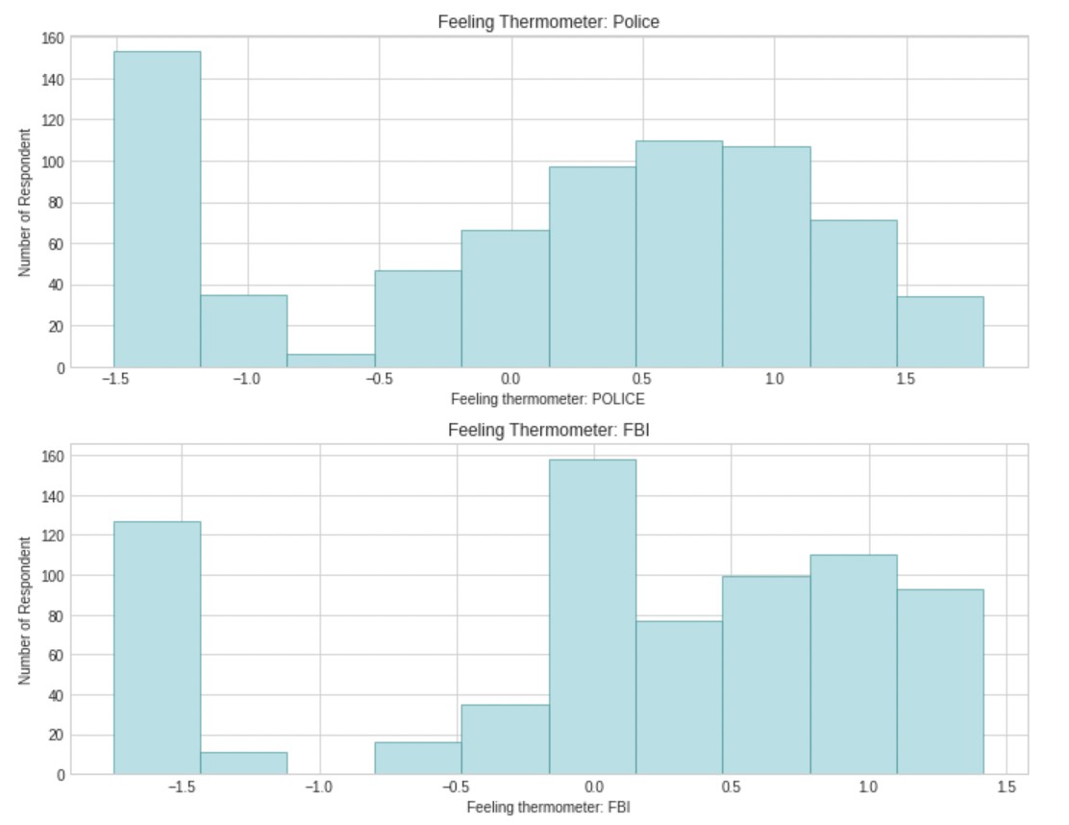

Figure 5(a). Histogram of Independent variable Study 1

The figure 5(a) shows the histogram of the independent variable for the study 1. For both variables, the graphs demonstrate a large range over the scale. However, the majority of the characteristics indicate a hatred for the police.

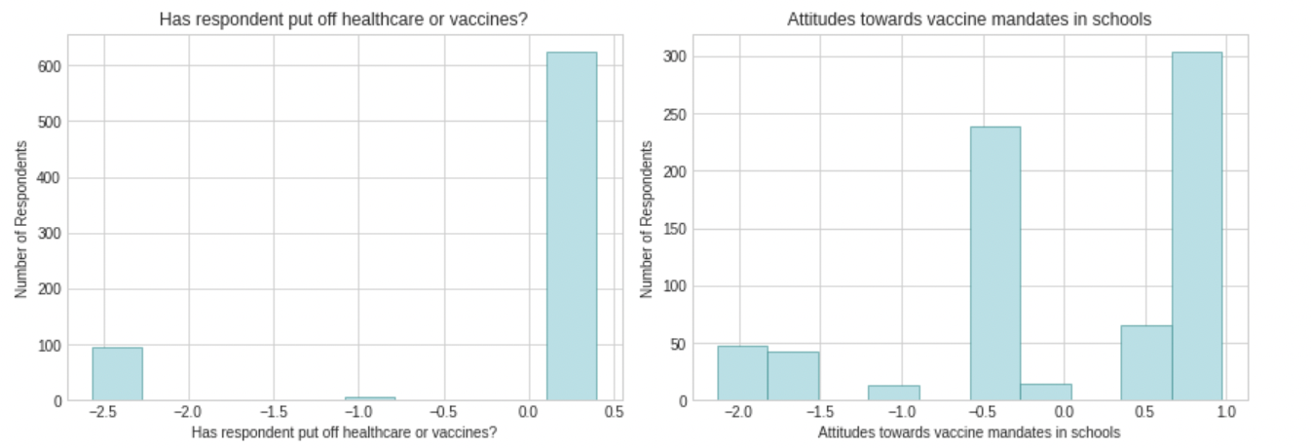

Figure 5(b). Histogram of dependent variable Study 1

The Figure 5(b) shows the histogram of the dependent variable for the study 1. For both the variables the respondent have shown a positive response towards vaccine mandates.

*Study 2: ANES 2016 vs. ANES 2020*

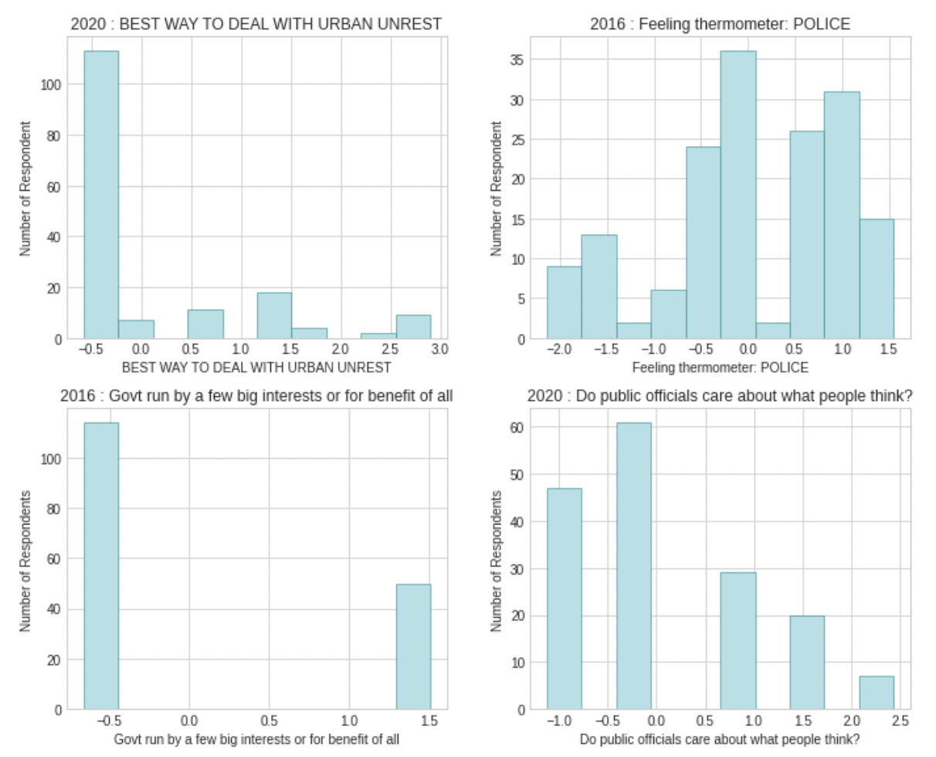

Figure 5(c). Histogram of independent variable Study 2

The figure 5(c) shows the histogram of the independent variable for the study 2. The variables demonstrate the spread over the scale.

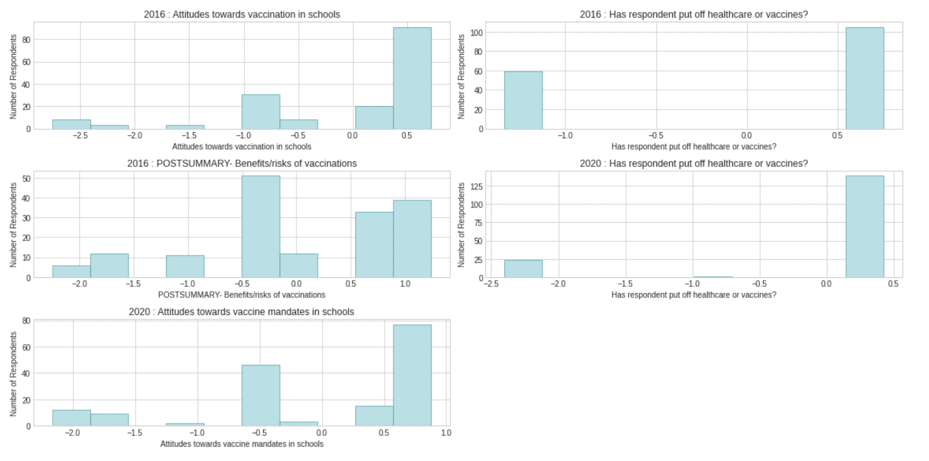

Figure 5(d). Histogram of dependent variable Study 2

The figure 5(d) shows the histogram of the dependent variable for the study 2. For both the variables the respondent have shown a positive response.

*Study 3: NYC geographical data*

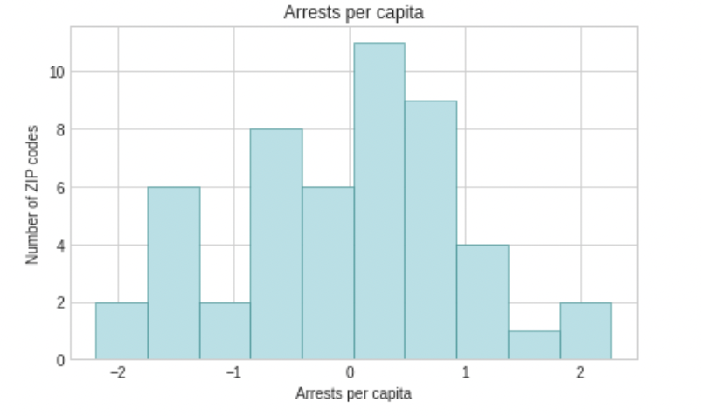

Figure 5(e). Histogram of independent variable Study 3

The figure 5(e) shows the histogram of the independent variable for the study 3. The variables demonstrate a uniform distribution across the range.

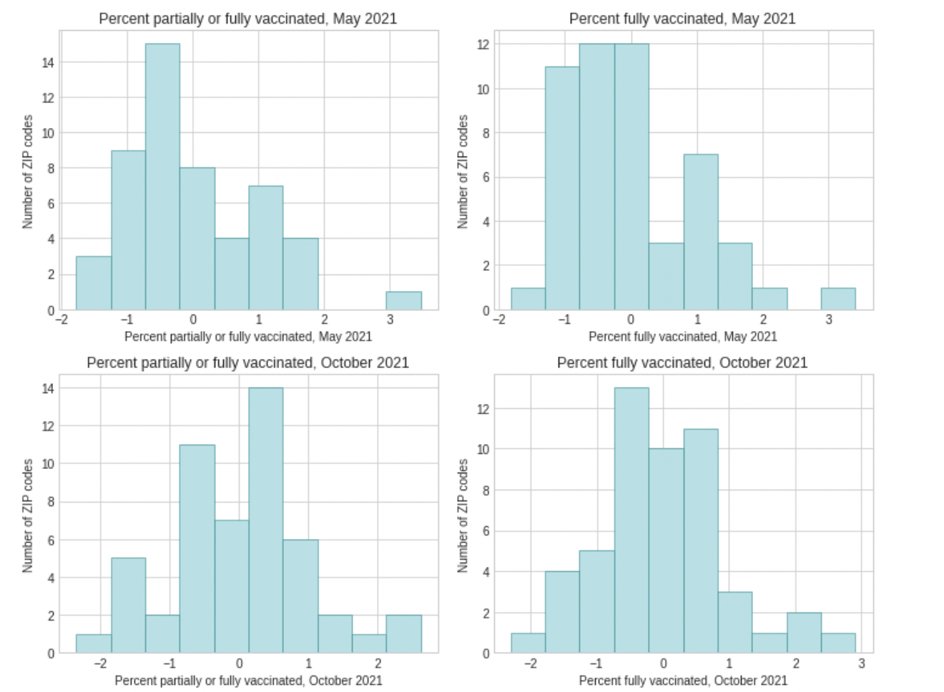

Figure 5(f). Histogram of dependent variable Study 3

The figure 5(f) shows the histogram of the dependent variable for the study 3. For the variable, the data was skewed towards the left .

For dependent variables that did not follow a normal distribution, we performed a Box-Cox transformation to turn the data into a normal distribution. Moreover, we also reverse scored arrests per capita in study 3 so its scale can be consistent with attitudes towards police in studies 1 and 2.

**Spearman correlation matrix**

Using a Spearman correlation matrix, we found a relationship between attitudes towards vaccine mandates and attitudes towards law enforcement in studies 1 and 2. We also found a stronger relationship between some vaccine outcome variables and arrests per capita in study 3 (less arrests per capita meant higher vaccine rates in our posttest variables).

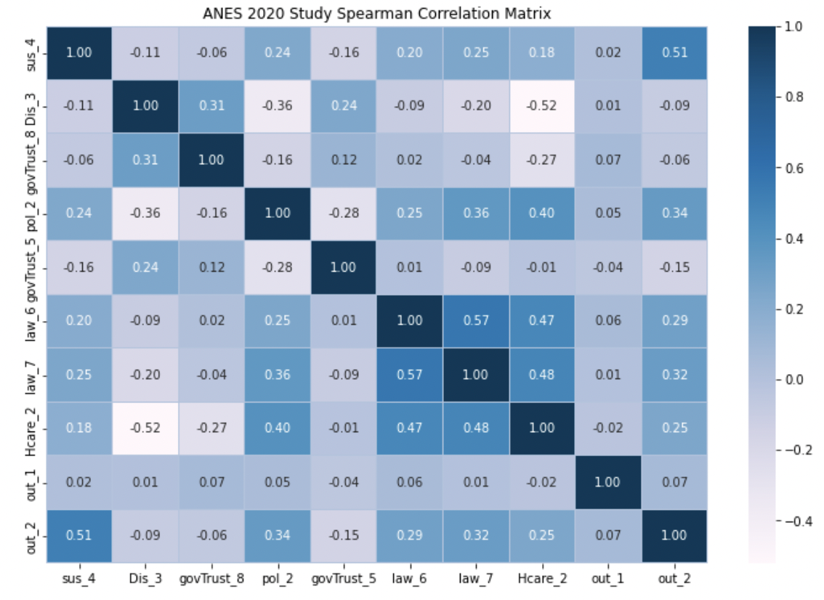

Figure 5(g). Correlation matrix for Study 1

The figure 5(g) shows the spearman's correlation matrix for Study 1.The plot is used to see the monotonicity of the data.

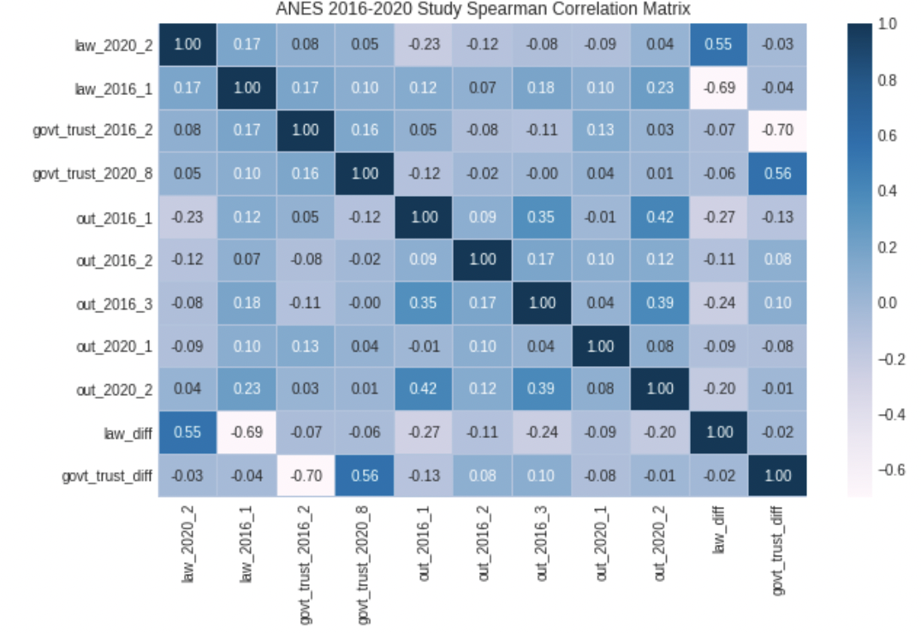

Figure 5(h). Correlation matrix for Study 2

The figure 5(h) shows the spearman's correlation matrix for Study 2.The plot is used to see the monotonicity of the data.

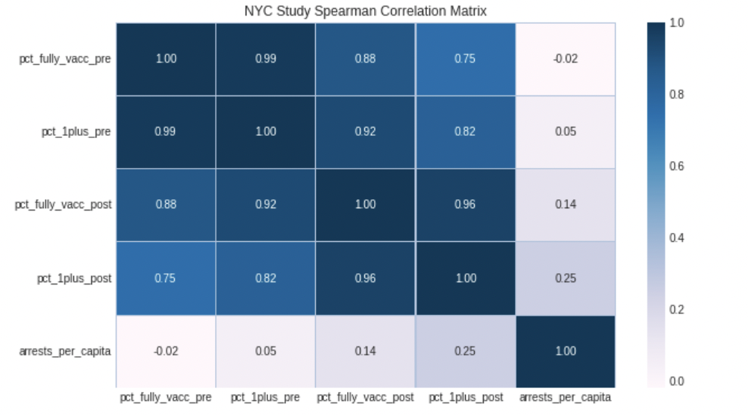

Figure 5(i). Correlation matrix for Study 1

The figure 5(j) shows the spearman's correlation matrix for Study 3.The plot is used to see the monotonicity of the data.

**Statistical analysis with Holm-Bonferroni Correction**

We then performed ANCOVA on our 3 studies, comparing each To determine our critical p-values, we started with a baseline significance level of 0.05 as this is the default variable. We did the Holm-Bonferroni correction on our critical values based on how many times we used each dataset and the ranked p-values. We highlighted analyses that are statistically significant (p-values from ANCOVA are below the adjusted significance level for each analysis). We mainly found statistically significant relationships between police attitudes and attitudes towards vaccine mandates in studies 1 and 2. In study 3, we found that the relationship between the level of police interactions interacting with the African Americans population percentage and vaccine rates is statistically significant. We also conducted a power analysis, we found that some analyses not statistically significant require an extremely large sample size to obtain an effect, indicating that there is probably no relationship between our hypothesized variables. However, study 2a indicates a sample size of 298 respondents is required, indicating that with more data points we may be able to have a better idea whether it is significant or not.

| **P-values ranked (ANES 2016/2020):** | | | |
| --- | --- | --- | --- |
| **Study** | **Treatment Group** | **Outcome variable** | **P-value** |
| 1b | Law_7  (Feeling Thermometer: FBI) | out_1(put off healthcare or vaccines) | 0.843392 |
| 1d | Law_6  (Feeling thermometer:Police) | out_1(put off healthcare or vaccines) | 0.327095 |
| 2a | Law_diff  (change in police attitudes from 2016 & 2020) | out_2020_2 (2020 Attitudes towards vaccine mandates) | 0.040394 |
| 2b | Law_2016  (Feeling thermometer(2016): POLICE) | out_2020_2 (2020 Attitudes towards vaccine mandates) | 3.908435e-03 |
| 1c | Law_6  (Feeling Thermometer:Police) | out_2(Attitudes towards vaccine mandates) | 2.688200e-12 |
| 1a | Law_7  (Feeling Thermometer: FBI) | out_2(Attitudes towards vaccine mandates) | 3.154086e-18 |
| **P-values ranked (NYC data):** | | | |
| 3a | Arrests_per_capita * pop_pct_black | pct_fully_vaccinated_post | 2.874877e-15 |
| 3b | arrests_per_capita* pop_pct_black | pct_1pluscinated_post | 3.177476e-10 |

Table 8. Statistical Analysis (ANCOVA)

| **Adjusted critical p-values (ANES 2016/2020):** | |
| --- | --- |
| 1b - 0.99/(6-6+1) | 0.05 |
| 1d - 0.05/(6-5+1) | 0.025 |
| 2a - 0.05/(6-4+1) | 0.0167 |
| 2b - 0.05/(6-3+1) | 0.0125 |
| 1c - 0.05/(6-2+1) | 0.01 |
| 1a - 0.05/(6-1+1) | 0.00833 |
| **Adjusted critical p-values (NYC data):** | |
| 3b - 0.05/(2-2+1) | 0.05 |
| 3a - 0.05/(2-1+1) | 0.025 |

Table 9. Type I error correction for the study

**Power analysis table**

| **Study** | **Treatment Group** | **Outcome variable** | **Sample size** |
| --- | --- | --- | --- |
| 1a | Law_7  (Feeling Thermometer: FBI) | out_2(Attitudes towards vaccine mandates) | 73 |
| 1b | Law_7  (Feeling Thermometer: FBI) | out_1(put off healthcare or vaccines) | 144290 |
| 1c | Law_6  (Feeling Thermometer:Police) | out_2(Attitudes towards vaccine mandates) | 114 |
| 1d | Law_6  (Feeling Thermometer:Police) | out_1(put off healthcare or vaccines) | 5862 |
| 2a | Law_diff  (change in police attitudes from 2016 & 2020) | out_2020_22020 Attitudes towards vaccine mandates) | 298 |
| 2b | Law_2016  (Feeling thermometer(2016): POLICE) | out_2020_2(2020 Attitudes towards vaccine mandates) | 184 |
| 3a | Arrests_per_capita * pop_pct_black | pct_fully_vaccinated_post | 15 |
| 3b | arrests_per_capita* pop_pct_black | pct_1pluscinated_post | 33 |

Table 10. Power Analysis

From table 10. The Study 1b, 1d, and 2a were not significant. Some of these traits required a marginally large sample size to achieve our target effect size and statistical power, which could lead to relevant results; others required a much higher sample size to achieve a modest effect size; the results for these analyses are unlikely to be meaningful.

The remainder of our research, which was significant, necessitates a lesser or about equal sample size to achieve our desired effect size and statistical power - this demonstrates that our results for significant tests are meaningful.

# Discussion

1. *Summary*

Our study can be summarized as mentioned below:

**Question:**

Do attitudes towards the police cause vaccine hesitancy amongst African Americans?

**Sampling Strategy:**

We used probability (random) sampling for ANES and modal instance sampling for the NYC arrest data study. We selected our data based on our population of interest for the study, and used multiple datasets to control for the limitations associated with the other datasets.

**Measurement Strategy:**

We used the constructs based on previous literature on vaccine hesitancy.These constructs were operationalised using the measures (features) of the ANES survey and NYC arrest data.

**Design:**

We used a series of multiple quasi experiments using non-equivalent treatment and control groups. The multiple studies controlled for the limitations which were identified in the other studies.

**Analysis:** We used ANCOVA for statistical analysis to control for the covariates that might confound the hypothesized relationship. We found meaningful statistical results in a few analyses. It highlights that police attitudes and interactions do have an effect on intentions to vaccinate but there are other reasons as well contributing to people getting vaccinated.

1. *Key insights and limitations*

* Based on our ANES survey results, police attitudes are associated with vaccine hesitancy amongst African Americans to a certain degree. However, the association of mistrust of government with vaccine rate influences attitudes towards vaccine mandates as opposed to vaccine uptake in general. This is indicative of mistrust towards the government in communicating public health, however we ruled out an overall mistrust in the government, which is consistent with the theory that police are the face of government for African Americans [8].
* We cannot determine how the relationship between police attitude and vaccine uptake varies when other confounders are controlled. A possibility is that while intentions to vaccinate and stances on vaccine mandates may be influenced by trust in the police, actual vaccine uptake may be influenced by other factors identified in the literature [1-10]. We can say that our statistically significant findings from study 3 reflect disparities in intentions to vaccinate due to police interactions, but based on our findings from studies 1 and 2, vaccine rates could have also been influenced by other factors.
* It is important to note that our findings cannot be generalized for the whole African American population. We need a sample that is indicative of the various subgroups within our theoretical population. We could not discern the various subgroups in the African American population in the ANES surveys. Moreover, our study using NYC data cannot be extended to other cities.
* It is also important to note that study 3 has only 1 independent variable which jeopardizes the reliability of arrests per capita as a measure of police attitudes.
* Multiple variables which could have impacted the vaccination rate did not contribute much to the variance of the dependent variables - these need to be addressed in further research.
* Some dependent variables are categorical and binary - logistic regression is a better fit if we were able to do the analysis again. In the interests of complexity, we decided to stick to ANCOVA for all analyses.

1. *Implications*

**Did our study findings answer our hypothesized study question?**

The question is partially answered as we can establish that the police attitudes influences attitudes towards vaccine mandates and intention to vaccinate to some extent, but the question is better answered by conducting more studies on actual vaccine uptake behaviors.

**Implications of the study findings:**

For relationships that we were not able to identify, we can conclude that researchers should study the additional relationships between police attitudes and the other factors that confounded the analyses. For example, there should be more research on the relationship between police attitudes and vaccine uptake, controlling for other factors that go beyond intention to vaccinate.

**Implications for decision-makers:**

We propose that the vaccine mandates should be reconsidered as they bring out a sense of racialized mistrust and state control among African Americans. We are able to say that vaccine mandates will work most effectively when constituents develop more trust in the government in tailoring towards minorities’ needs.

Vaccine uptake that goes beyond willingness to get vaccinated should be studied further and how interactions and police attitudes have an effect on people’s final outcome behaviors. We were able to study this relationship in NYC, but to be more confident, we will need to gather data from multiple areas to say more confidently that police had a direct influence.

1. *Next steps for further research*

Given our findings, we devised further steps that decision makers and researchers can take to obtain more robust results:

* Study the relationship between police attitudes and trust in the government amongst African Americans, and its implications on vaccine hesitancy.
* Study the relationship between police attitudes and actual vaccine uptake amongst African Americans, beyond willingness to get vaccinated.
* Study the relationship between the vaccine hesitancy and each of the variables ruled out from the study after factor analysis.
* Expand the sample from Study 3 (NYC data) to multiple cities.
* Identify confounding factors from public health experts.
* Rule out the factor of distance and ease of access to vaccine clinics.
* Use continuous dependent variables when performing ANCOVA, or use logistic regression when performing analysis on binary data.

# References

1. Bajaj, Simar Singh, and Fatima Cody Stanford. “Beyond Tuskegee - Vaccine Distrust and Everyday Racism.” *The New England journal of medicine* vol. 384,5 (2021)., https://doi.org/10.1056/NEJMpv2035827
2. Jennifer Tolbert, Kendal Orgera. “Vaccination Is Local: Covid-19 Vaccination Rates Vary by County and Key Characteristics.” *Kaiser Family Foundation*, Kaiser Family Foundation, 12 May 2021.
3. Bogart, Laura M., Lu Dong, Priya Gandhi, Samantha Ryan, Terry L. Smith, David J.Klein, Luckie-Alexander Fuller, and Bisola O. Ojikutu, What Contributes to COVID-19 Vaccine Hesitancy in African Communities, and How Can It Be Addressed?. Santa Monica,CA:RAND Corporation, 2021 <https://www.rand.org/pubs/research_reports/RRA1110-1.html>
4. Dunbar, Adam, and Nicole E. Jones. “Race, Police, and the Pandemic: Considering the Role of Race in Public Health Policing.” *Ethnic and Racial Studies*, vol. 44, no. 5, 2020, pp. 773–782., https://doi.org/10.1080/01419870.2020.1851381.
5. Bunch, Lauren. “A Tale of Two Crises: Addressing Covid-19 Vaccine Hesitancy as Promoting Racial Justice.HEC forum:an interdisciplinary journal on hospitals’ ethical and legal issues vol. 33,1-2 (2021): 143-154.doi:10.1007/s10730-021-9440-0
6. Fox, Maggie. “Unvaccinated People Are 'Variant Factories,' Infectious Diseases Expert Says.” *CNN*, Cable News Network, 4 July 2021.
7. Quinn, Sandra Crouse, et al. “Breaking down the Monolith: Understanding Flu Vaccine Uptake among African Americans.” *SSM - Population Health*, vol. 4, 11 Nov. 2017, pp. 25–36., https://doi.org/10.1016/j.ssmph.2017.11.003.
8. Rosenthal, A., Motta, M., & Farhart, C. E. (2021, July 5). Beyond Tuskegee, To Middlesboro: How Perspectives of Policing Shape Vaccine Attitudes for African Americans.https://doi.org/10.31235/osf.io/wjq4a.
9. Warren, Rueben C et al. “Trustworthiness before Trust - Covid-19 Vaccine Trials and the African Community.” *The New England journal of medicine* vol. 383,22 (2020): e121.doi:10.1056/NEJMp2030033.
10. Zainab Toteh Osakwe, Jennel C. Osborne, Nonso Osakwe, Ana Stefancic, Facilitators of COVID-19 vaccine acceptance among African and Hispanic individuals in New York: A qualitative study, American Journal of Infection Control,Volume 50,Issue 3, 2022, Pages268-272,ISSN0196-6553,<https://doi.org/10.1016/j.ajic.2021.11.00>
11. Bogart LM, Ojikutu BO, Tyagi K, Klein DJ, Mutchler MG, Dong L, et al. COVID-19 related medical mistrust, health impacts, and potential vaccine hesitancy among Black Americans living with HIV. *J Acquir Immune Defic Syndr.* 2021;86(2):200–207. doi: 10.1097/QAI.0000000000002570.